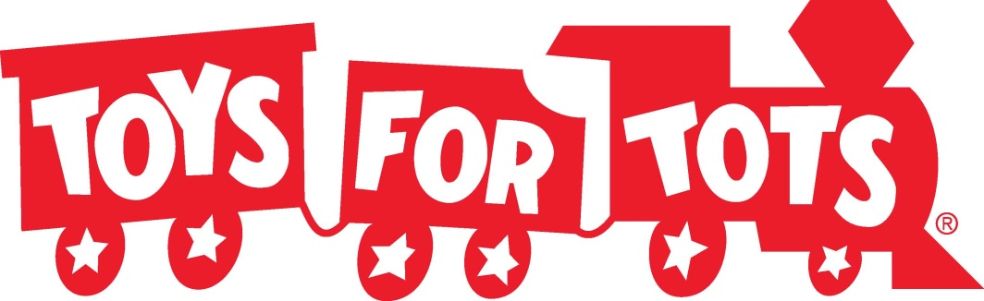

The Galien Township Library is a drop off spot for Toys for Tots monetary & toy donations! We can also help you sign up if your family would like to
receive donations from
Toys for Tots. Stop on in!

